Building a cyberdeck – documentation

Basic steps to building:
- Research and idea building– researching what other people have done with their cyberdecks aesthetically – sizes, shapes, what containers to use/design etc. Then, research on electric components – what mainboard to use, keyboard, screen, battery/power connector etc. for the basics. Further components – USB hubs, Wi-Fi connectivity, buttons etc.
- Initial CAD – designing the case, the slots for the components to sit – testing using placeholders etc.
- Production and installation – Produce the final versions of the components, order the hardware, solder it all together and install into the case (maybe program first, depending on difficulty), finalise design.
- Software – installing operating systems, connecting components together, downloading software etc.

STEP 1: RESEARCH:
Inspiration photos

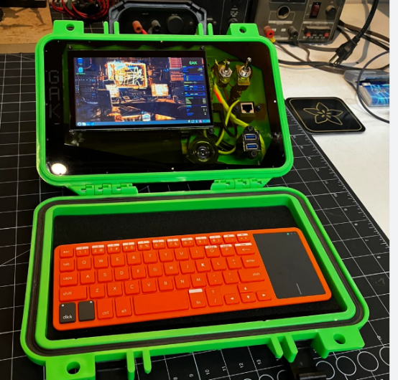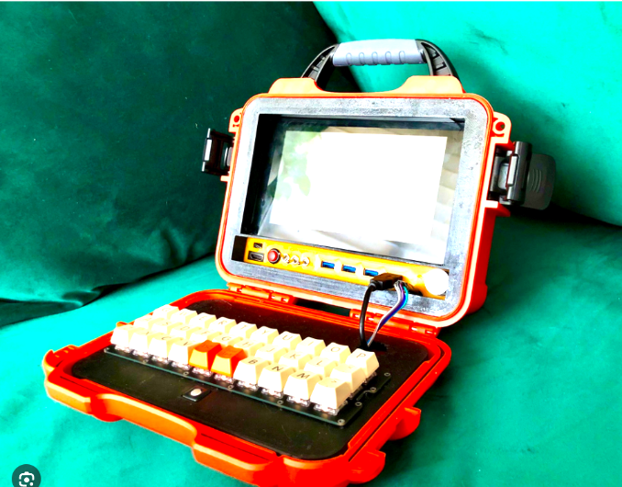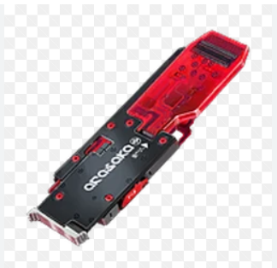
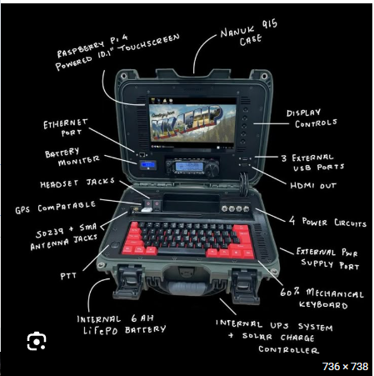
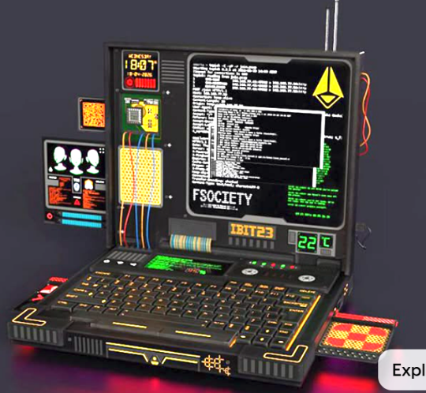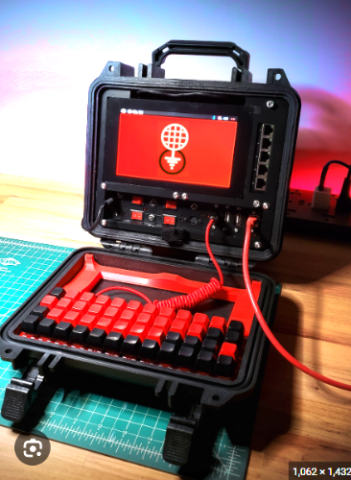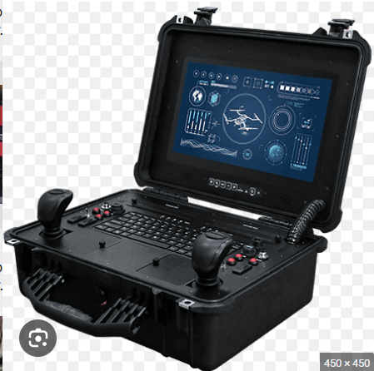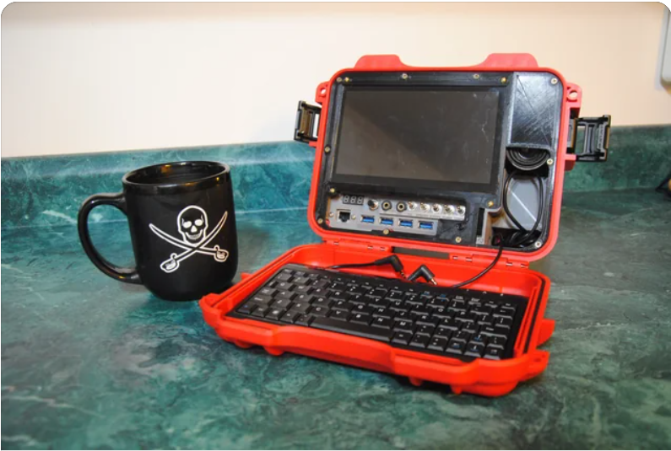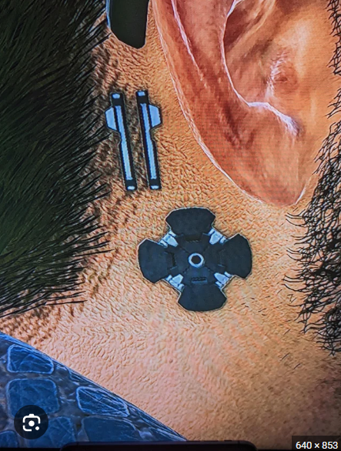

Idea building
Essentially – a cyberpunk themed cyberdeck. It should have basic computer functionality using some sort of small computer board – probably a raspberry Pi. It’ll have a keyboard and screen integrated, but a wireless mouse separately. I’d like it to have some sort of USB ports, probably using a usb hub that has the ports sat on the bottom half of the deck, and I’d quite like to have in in the style of a Neural port from cyberpunk (decorative only) as well as an audio port in the style of the personal link port (from the game). It should have WiFi connectivity, but that’s not an initial priority for it. Maybe I’ll also add an ethernet port, mostly for aesthetic purposes. It will need a power port of some sort somewhere, but I’m not sure if I want it to run off a battery or a wire. Maybe both, but I’m not sure how to do both now. A small screen for a battery monitor would be cool as well. It would also be cool to use the cyberdeck USB ports as an upgrade port as well, so that I could add more features in the future easily. For WiFi, it would need external antenna, so those would have to fit in somewhere. The whole cyberdeck should be able to fold shut, for transportation.

Electronics/components research
List of electronic components I might need:
- Computer – the main computer for the cyberdeck. I’m going to use a raspberry pi, either the 3 or 4. The 4 seems better value – I think the 1gb ram is best, as the project is on a budget, and I can always upgrade the board later. Maybe use pi5 if budget allows. Approx. £33
- Keyboard – a keyboard to integrate into the cyberdeck. Needs to be small, and able to fit nicely into the case. Also needs to be able to be strongly fixed in place somehow. Some sort of cheap amazon keyboard. Approx. £6
- Main Screen – a screen to show the display of the computer. Ideally colour-enabled, but resolution and refresh rate can be low. Size needs to be 10-15cm wide and 7-12cm tall approx. https://shorturl.at/wK7ne from ali - good option. Approx. £36
- Secondary screen – next to the main one
- Battery/Power connector – for power for the components. Battery makes it portable, but power cable is probably cheaper/easier. Also battery requires charging board, and idk about those. I’m going to use a power cable -cheaper, easier. Can add battery later. Can use standard usb-c cable as power, so no charge there, but need usbc-f to usbc-m to take power from outside of case so approx. £3
- Ethernet-to-ethernet cable – to extend the ethernet port from the pi board. I plan to initially use ethernet for internet connection as I think it’s easier (unless the computer has wifi built in) approx. £2
- Audio jack extender – for the audio port on the deck. Approx £1
- USB hub- for getting more USB ports. Approx. £3
- Small fan for cooling computer board. Approx. £
List of electronic components I already have:
- Wires – wires to connect the components (apart from the high-gauge wires for power)
- Screws/bolts – for connecting things to the case
- Hard drive for storage for the pc
List of non-electronic components I need:
- 3D printing filament – something strong, and rigid, and that won’t decay over time. Ideally PETG or PCTG, as they are the strongest filaments I can safely print on my A1. PCTG is quite a bit more expensive, but also a bit stronger than PETG. I intend to use white filament so that anything I print can be easily painted over. Potentially, I’ll use white PCTG for only the outside case and then cheaper PETG for anything inside that is less structurally important. This would save costs. Already have PETG, assume ½ kilo of PCTG, so approx. £11
- Metal rods – for the hinges of the case. use, approx. 4 Approx. £3
- Heat-set inserts – for screwing things into the case (maybe not needed). approx. £2
- Small heatsink for pi board. Approx. £4

Total approx. cost (very rough) = £101, $140
$140 dollars is 28hrs of work with grants from fallout, so some will probably be self-funded? Things to complete that are time-heavy is CAD, Installation, Software, and decoration etc.

STEP 2 – 3D modelling
CASE:
Case features:
Max 256mm square (3d print limits)
Ideally rectangular (1:1.3 size ratio)
Handle
Hinges
Should look like a carry case when closed

Dimensions:
I think about 23cm by 17.5cm is ideal, as it leaves plenty of space on the printer. Depth should be enough to store all components, but not too big. Start with 4cm deep
Internal dimensions (mm):
169.2 x 224.2 x 40 – main body
179 x 234 x 2 – lip at top

Useable base dimensions (need to print base parts separately as can’t print upside down):
160.3mm x 215.3mm
Will glue into case after printing

MODELLING SPACES FOR COMPONENTS
I need to model in spaces for components to fit – for parts I know what they will be, I’ll do it exactly, and for others, I’ll do it for a generic part that should be approx. the right size
Parts I know:
- Raspberry Pi 4
- 7 inch raspberry pi screen (need top half)

Generic parts:
- Keyboard (temp)
- Power cable connectors/ports (will vary largely in size, so may leave generic until purchases are made)
- 30mm fan
- USB hub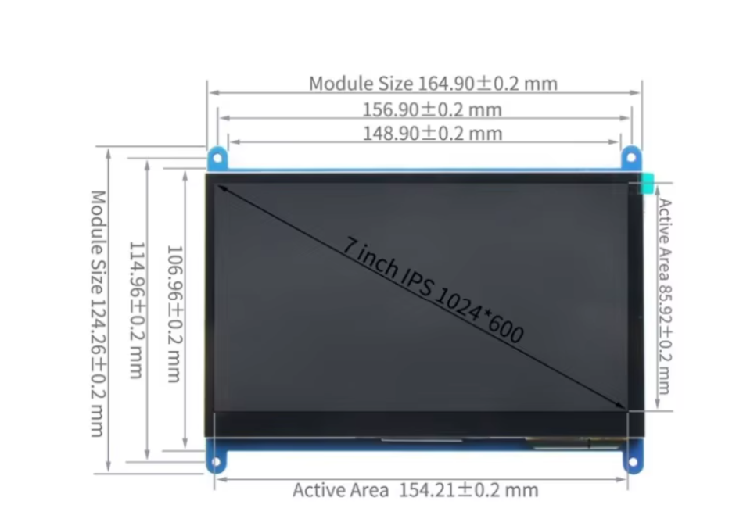

List of things that need changing after purchasing components:
- Screen hole
- Usb dock holesx

Fixing the files for final production
What needs fixing:
- Add a hole for the ethernet cable connector on the back(DONE)
- Move USB ports and make an accurate holder for the hub(DONE)
- Make a way for cables to go from lower case to upper case (potentially combine with 1?) (DONE) (cables will be wrapped in electrical tape and a stopper will limit the angle of opening)
- Build stopper for the cables to limit case angle (DONE)
- Check fit for screen(DONE)
- Check hole sizes for all screws+inserts

Test prints before final print:
- Usb hub(DONE)
- Keyboard(DONE)
- Rear ethernet and usb-c holes (DONE-PERFECT)
- Display(DONE)(maybye redo?)

- Cable clips(DONE-PERFECT)

Screws/screw types needed:
8x m4 for hinges (+inserts)
16x m3 for case covers(+inserts)
8x m3 for usbhub and keyboard(+inserts)
4x (unknown, m2.5-3ish) for display
4x m2.5 for pi 5(screw straight into plastic?)
4x m2/2.5 for fan(need 4x small nut to hold it)
4x (same as display) for ethernet and usbc ports
Further features to decide on adding:
- Handle
- Locking clasps

